2.Create a simple cloud software application for Property Buying & Rental process (In Chennai city) using any Cloud Service Provider to demonstrate SaaS include the necessary fields such as Buy, Rent, commercial, Rental Agreement , Rental Agreement, Area, place, Range, property value etc.

Step 1: create the buyer details

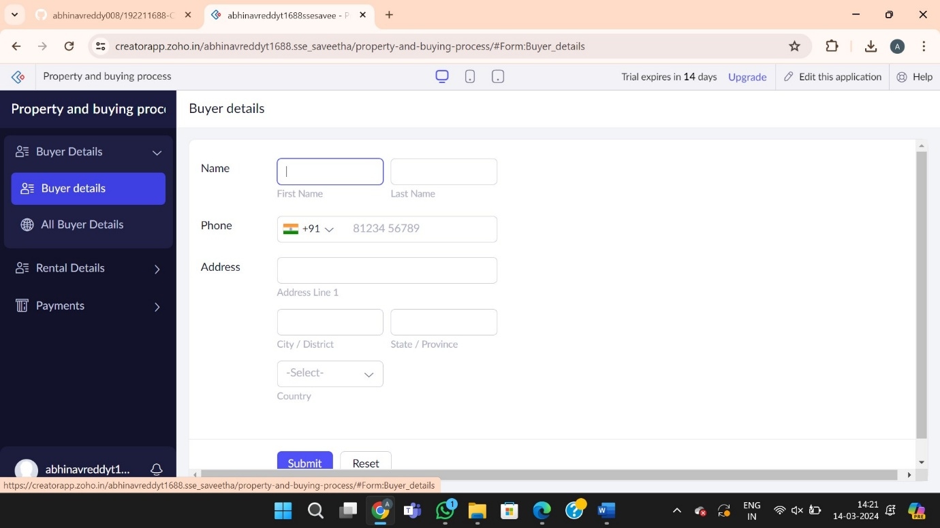



Step 2:Create the Rental details

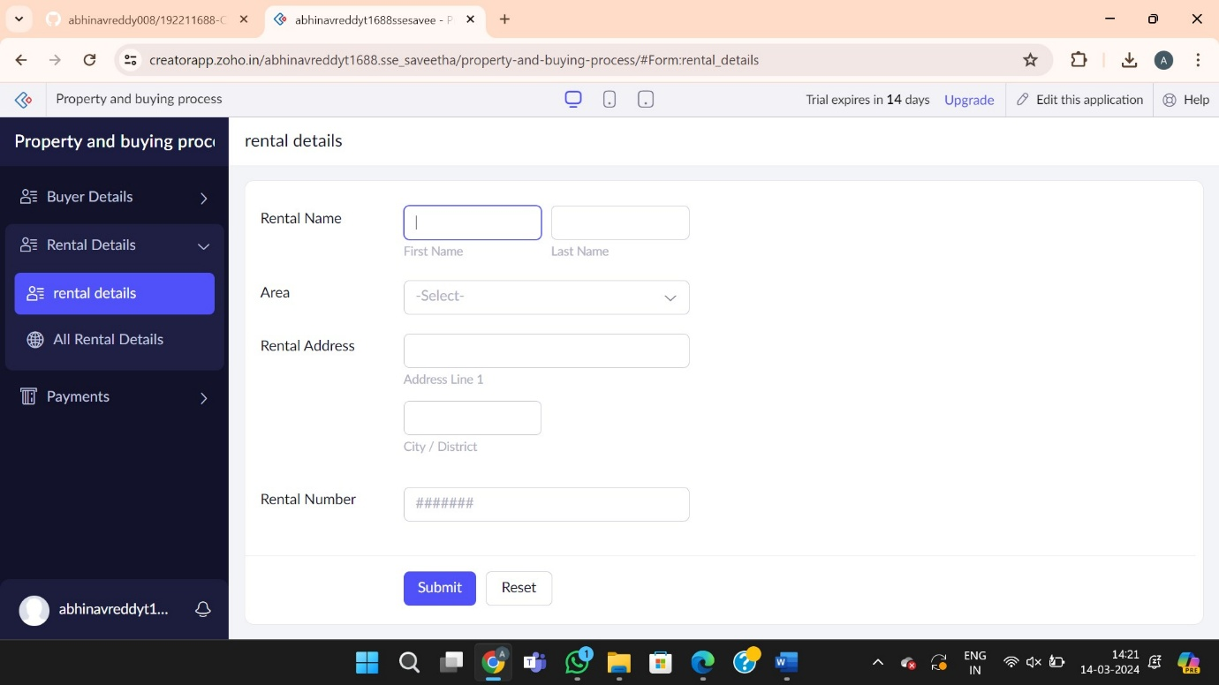

Step 3: Create the payment form



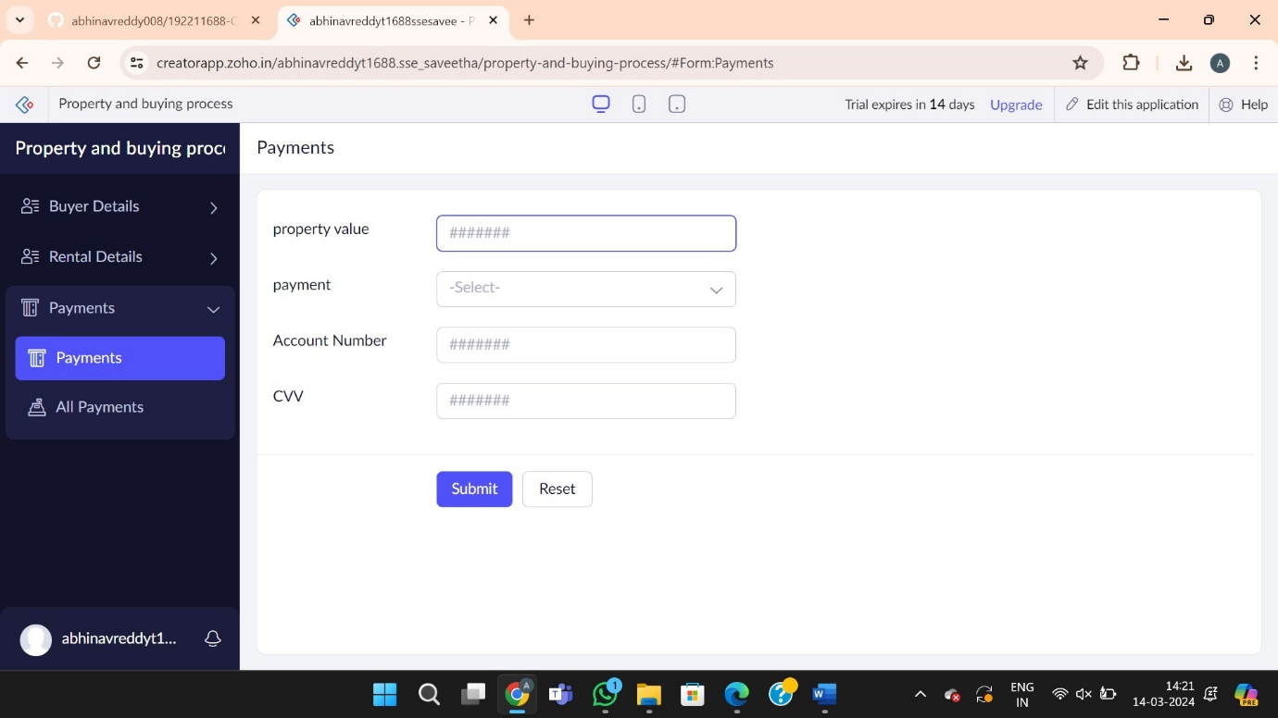

Step 4: Report forms

